MYCO SEED TREAT®
Commonly referred to as MST
LOT# NET WT #

MYCO SEED TREAT (commonly referred to as MST) is a dry blend of plant-beneficial bacteria and fungi (including Mycorrhizae) accompanied by a nutrient package to support them during their initial stages of growth.
SUGGESTED USES
May be used on all crops.
Commonly mixed into seed box on planter.

RECOMMENDED RATE:
Adjust rates according to seed size. Smaller seeds have more surface area to coat. The goal is to coat all of the seeds. Below are suggested guidelines for determining rates.

4 ozs /100# seed recommended for large seeds such as corn and soybeans
6 oz /100# seed recommended for medium size seeds such as sorghum or sudan grass 8 -12oz/100# seed recommended for small seeds such as grass, clover and alfalfa
For potting mix or transplants: 4# / cu. yd. OR 1# / 500 plants (1/4 teaspoon/plant)

SLIGHTLY ROUNDED SCOOP HOLDS 8 oz. (scoop enclosed)


STORAGE AND HANDLING
Keep product dry.
Store out of direct sunlight. Store below 90°F.

When using dry products, always use proper safety equipment (dust masks, goggles, gloves)

Myco Seed Treat meets National Organic Program requirements for organic production.

Myco Seed Treat contains NO Genetically Modified Organisms.

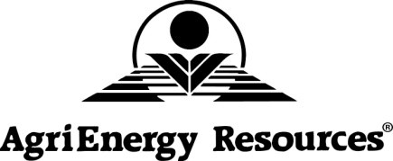
This product is intended for use according to an approved organic system plan.
It is each certified organic grower’s responsibility to get approval from his/her certifying agency before using this product. Because of differences among the various certifying agencies, and differences between NOP/EU/JAS/COR ingredient lists, AgriEnergy Resources cannot guarantee that our products will be allowed by your certifier on your farm.

21417 1950E Street ● Princeton, IL 61356 ● (815) 872-1190 ● info@agrienergy.net

20200301

